#Practical 1: Mining Twitter: Exploring Trending Topics, Discovering What People Are Talking About, and More: Why Is Twitter All the Rage?, Exploring Twitter’s API, Fundamental Twitter Terminology, Creating a Twitter API Connection, Exploring Trending Topics, Searching for Tweets, Analysing Tweets and Tweet Entities with Frequency Analysis.

**Roll No.:-**

#Practical1.py import tweepy

#Authenticate to Twitter

Auth=tweepy.OAuthHandler("M42RKxXEWKwj3nlldJvCbJS5Y","UL hQ6WzoaBTpGVG7liGxbwsoQqiFRgh6Lh7SWmh2VqAqDGmhiR")

auth.set_access_token("1757656639291924480- tEVVypc7XoCSRO3mPSc1CbGzxP2aE9","HIEe1Jxoc9ZUX1evsUhmr 9c0s38UbhA8Q87AWrFKc9k3m")

api = tweepy.API(auth) try:

api.verify_credentials()

print("Authentication OK") except:

print("Error during authentication")

# Retrive trending topics for aspecific location(WOEID 1 in this example) trends = api.get_place_trends(1)

# Print the trending topics

for trend in trends[0]['trends']: print(trend['name'])

# #OUTPUT

Authentication OK

#Twitter Developer Portal

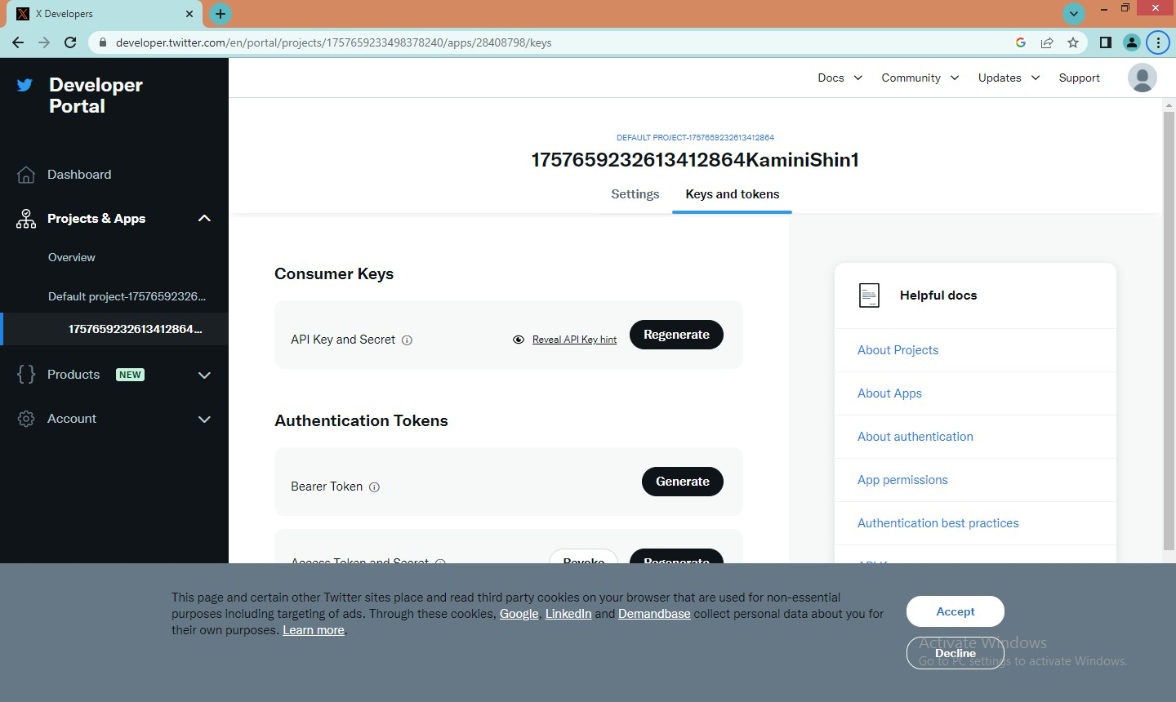

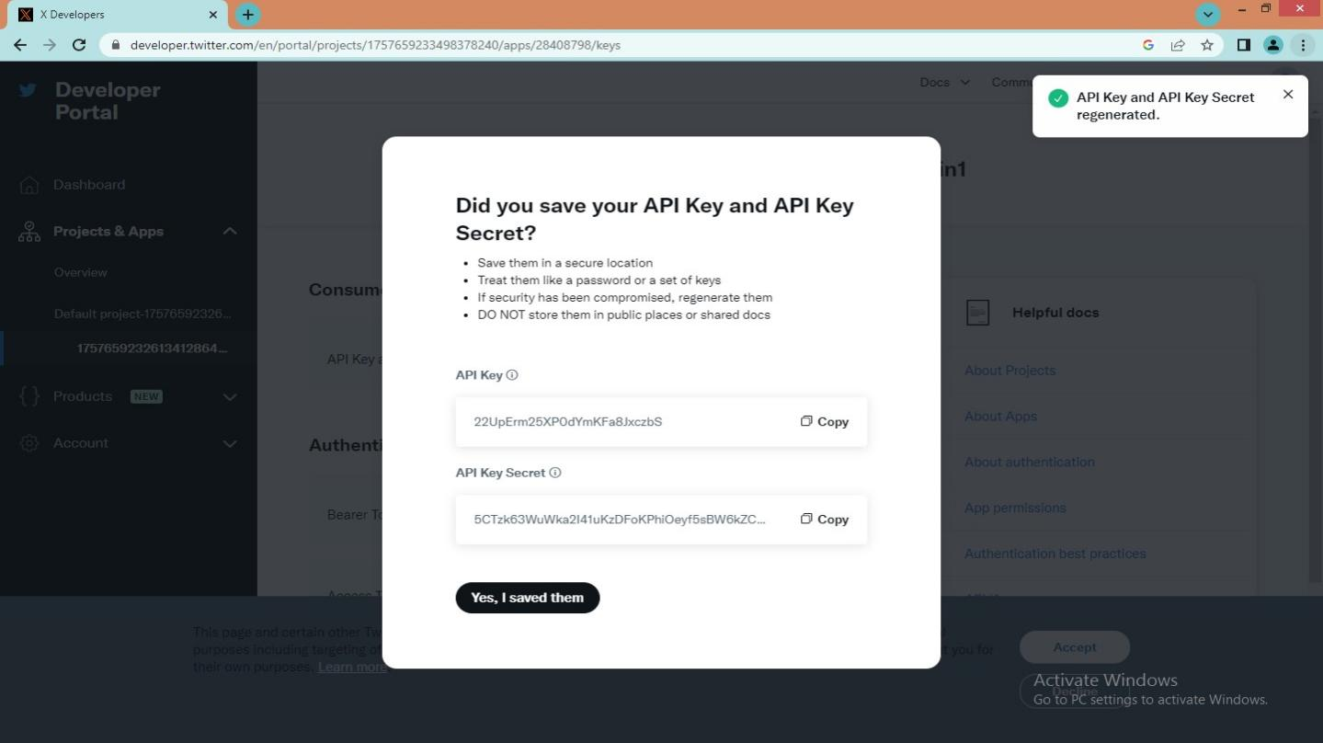

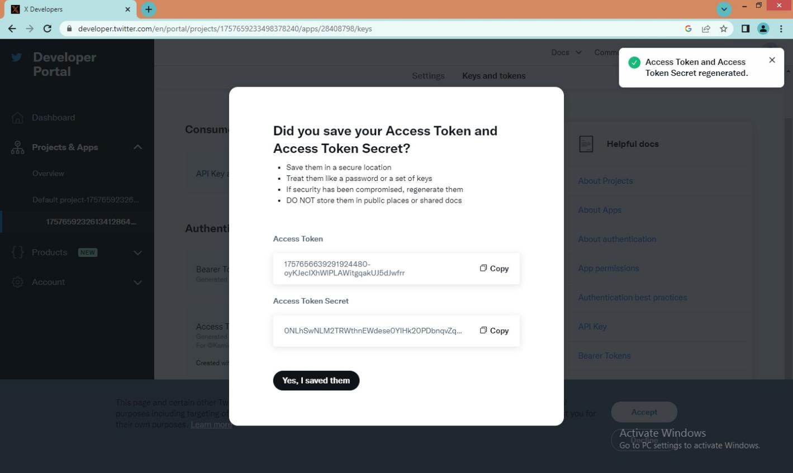

The consumer Key,consumer key secret,access token and access token secret are used from the above developer portal in the python script #Practical1.py

# Practical 2: Mining Facebook: Analyzing Fan Pages, Examining Friendships: and More Overview, Exploring Facebook’s Social Graph API, Understanding the Social Graph API, Understanding the Open Graph Protocol, Analyzing Social Graph Connections, Analysing Facebook Pages, and Examining Friendships.

**Roll No.:-**

**Step 1:** First, Go To The Developer.Facebook.Com

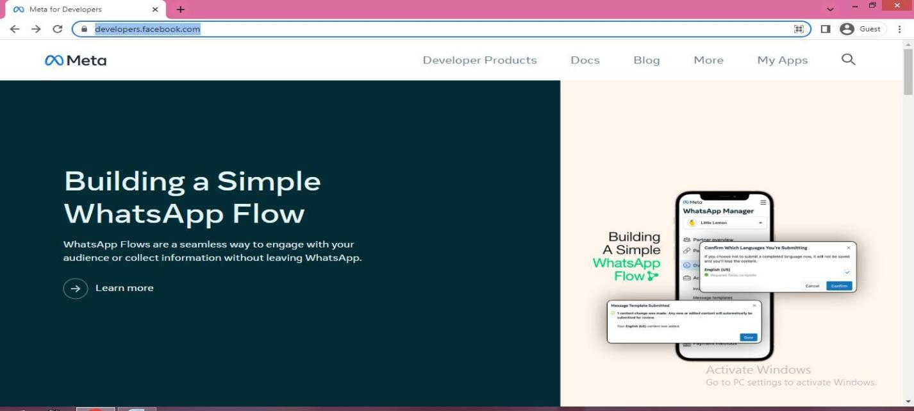

**Step 2:** In More Option , Select Tools.

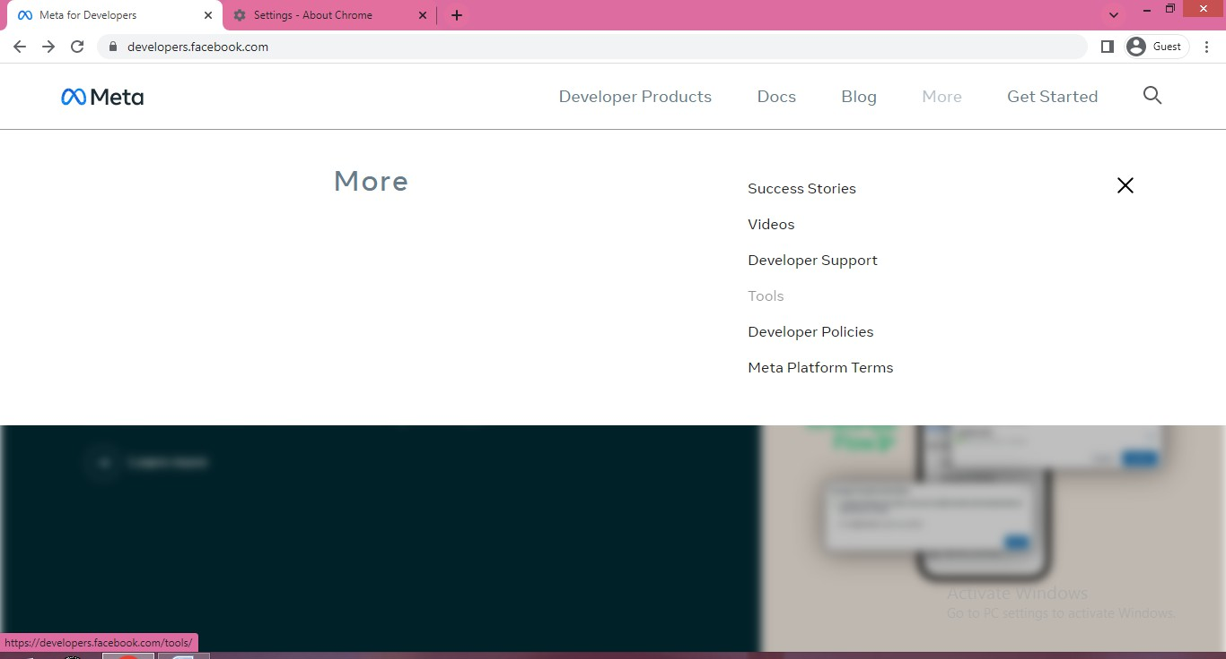

**Step 3**: In Developer Tools Select Graph AP I Explorer

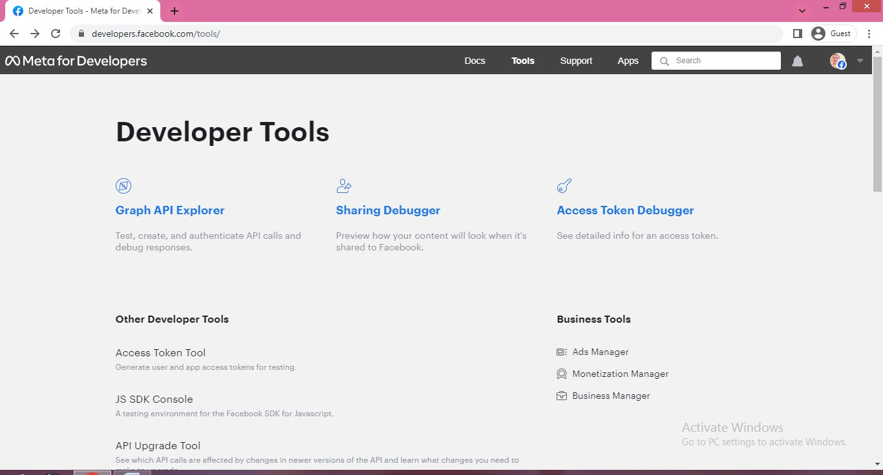

**Step 4:** Click On Register.

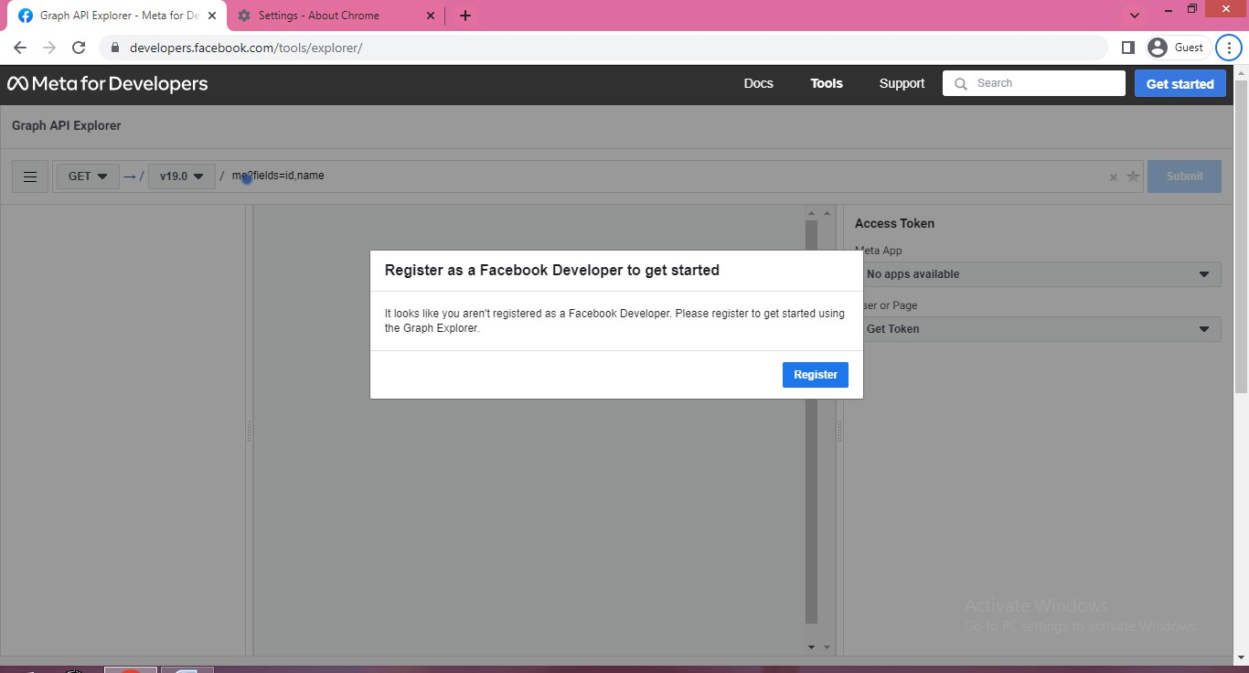

**Step 5**: Choose The Student Option

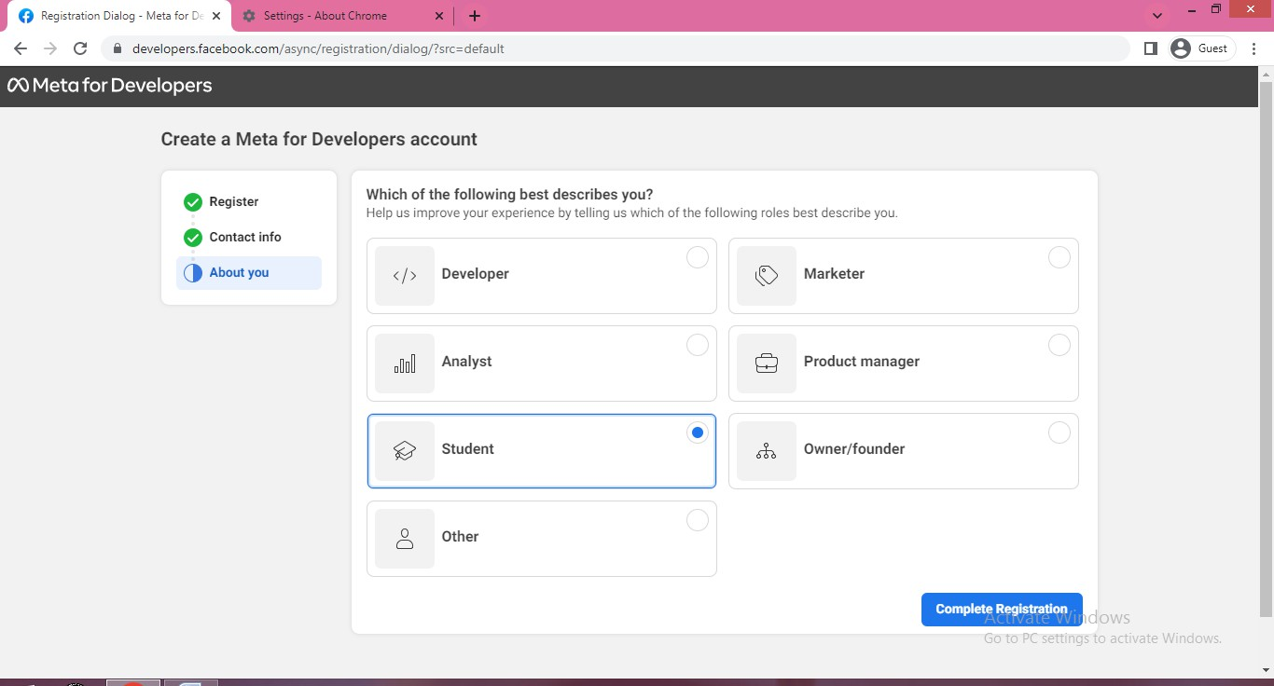

**Step 6:** Select All Apps And Click On Create App

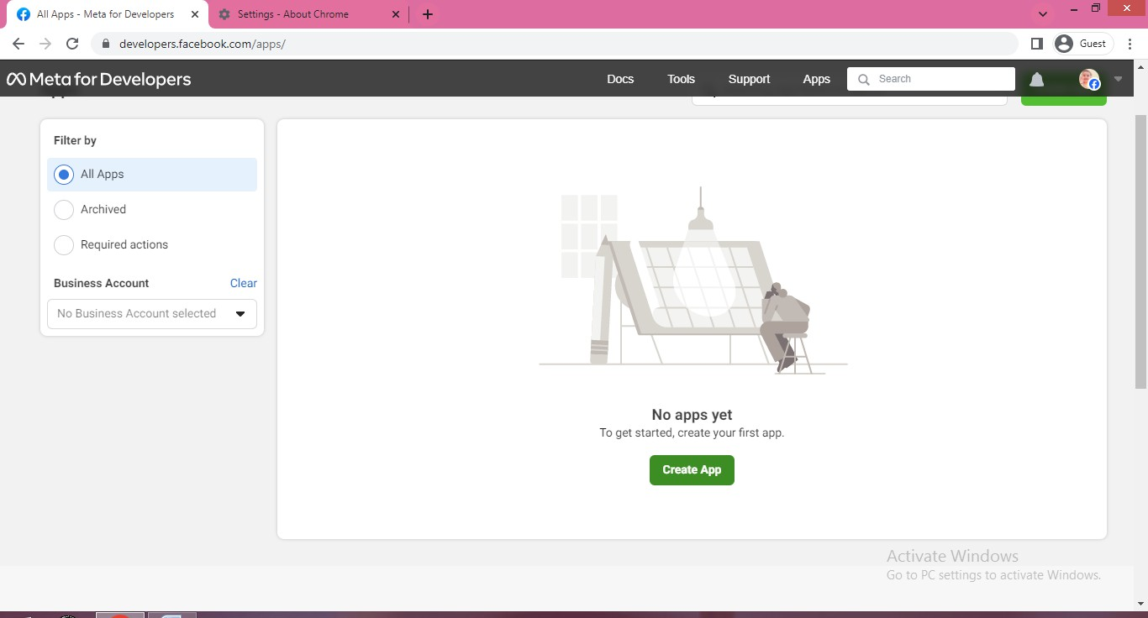

**Step7:** Select Option Facebook Authentication And Click On Next Button

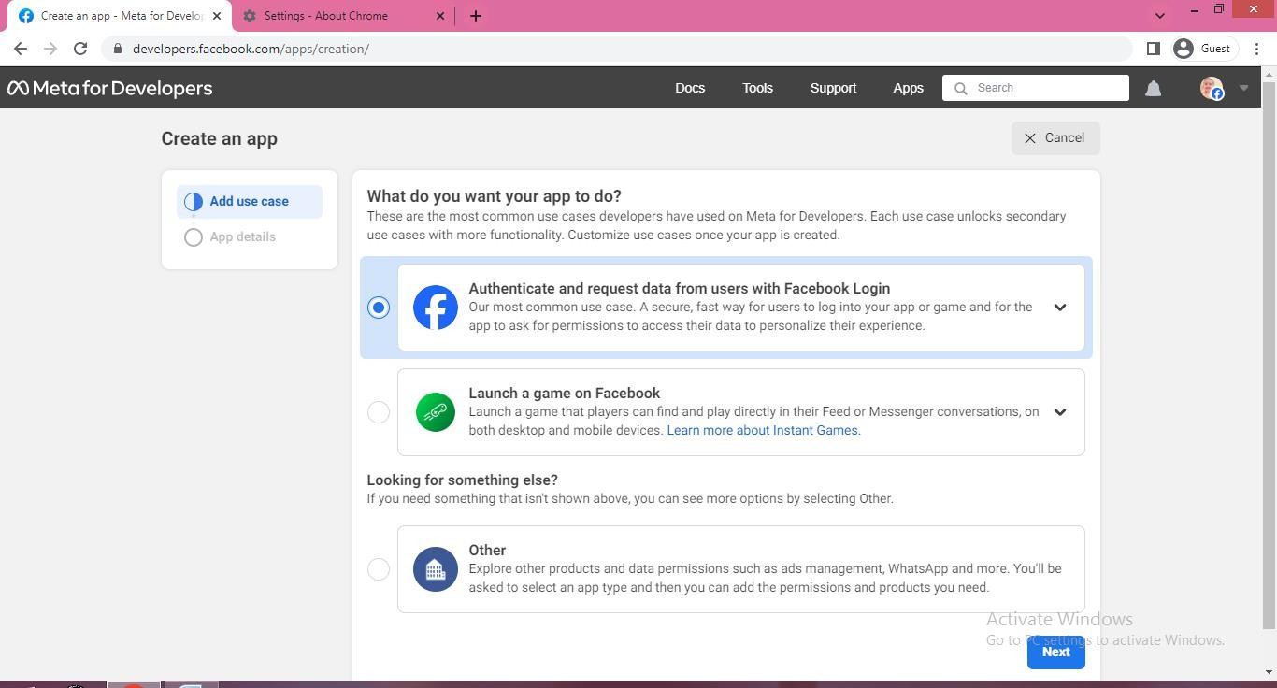

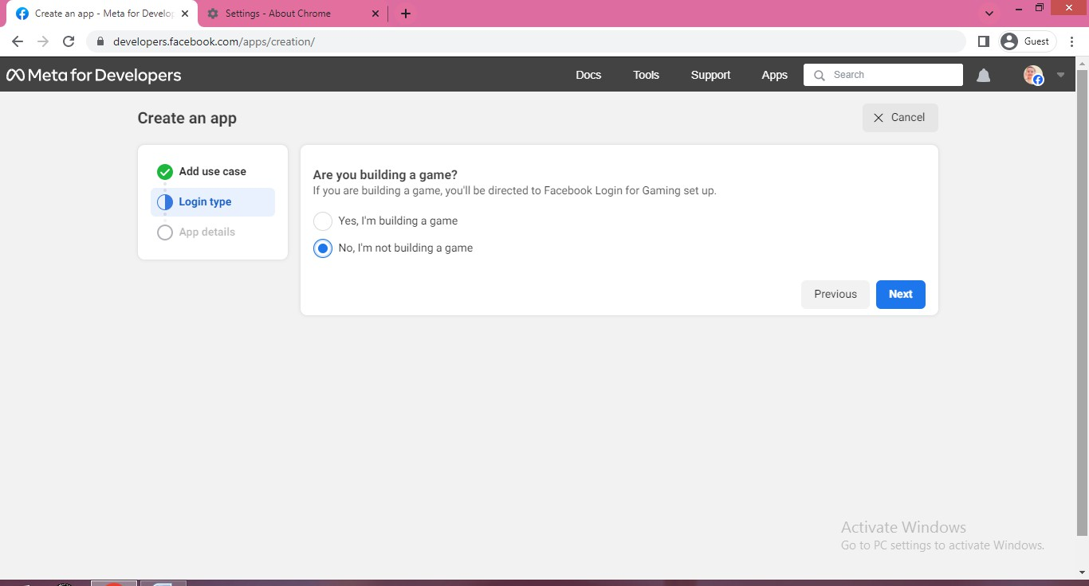

**Step 8**: Write The Add App Name To Create App(Mining Analyzing Pages)

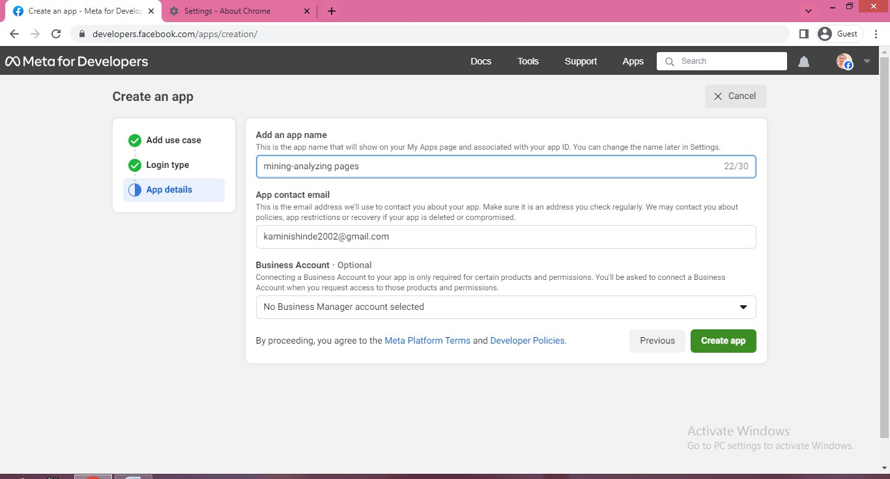

**Step 9:** Choose First Option Customize This App

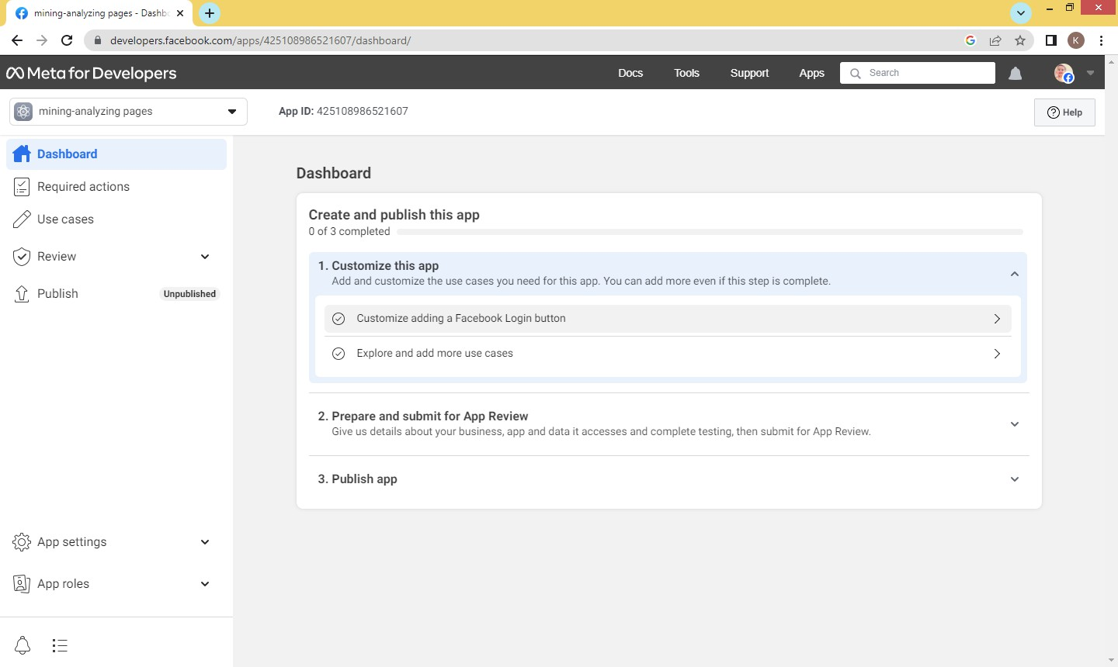

**Step 10**: Select Generate The Access Token And Submit Button

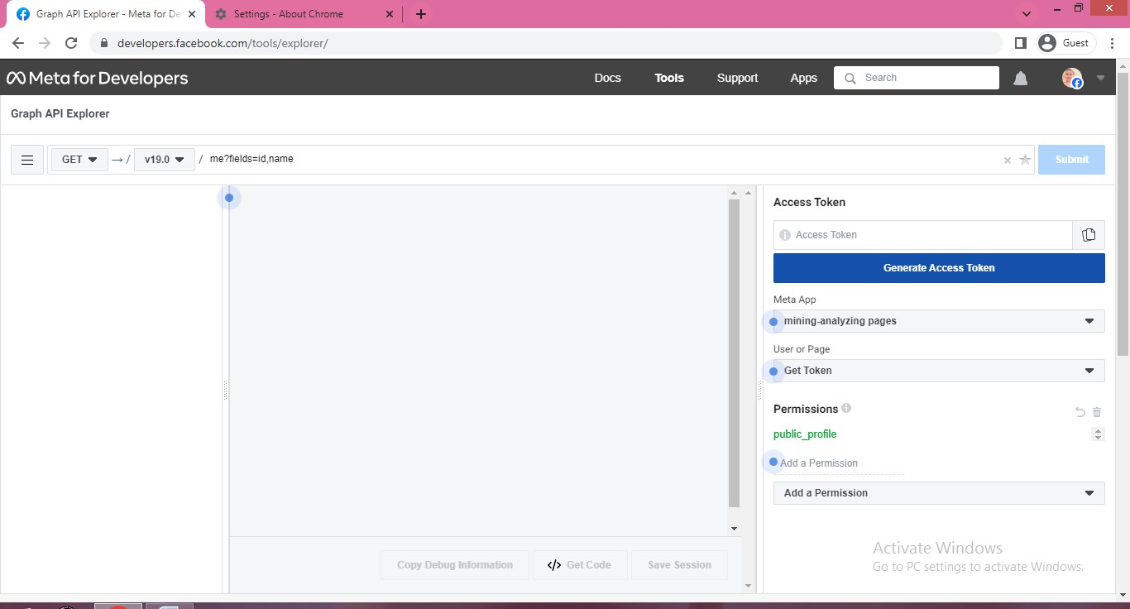

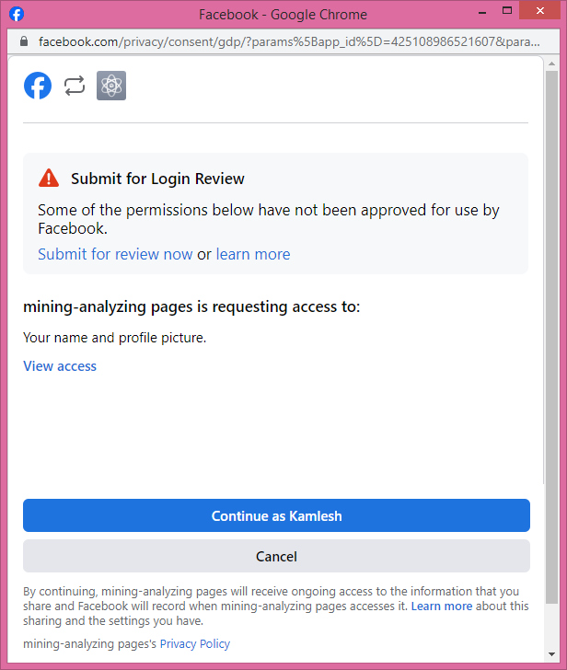

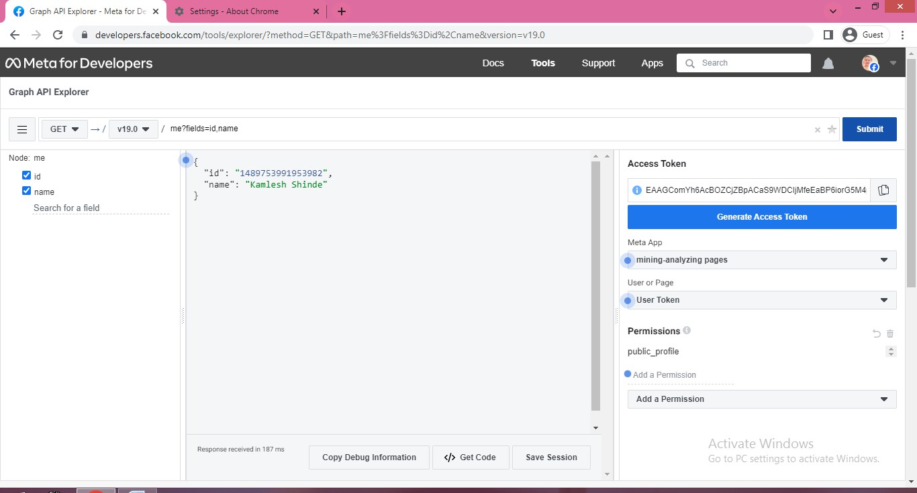

**Step 11**: Choose First Option Customize This App



**Step 12**: Add Email Field To Access

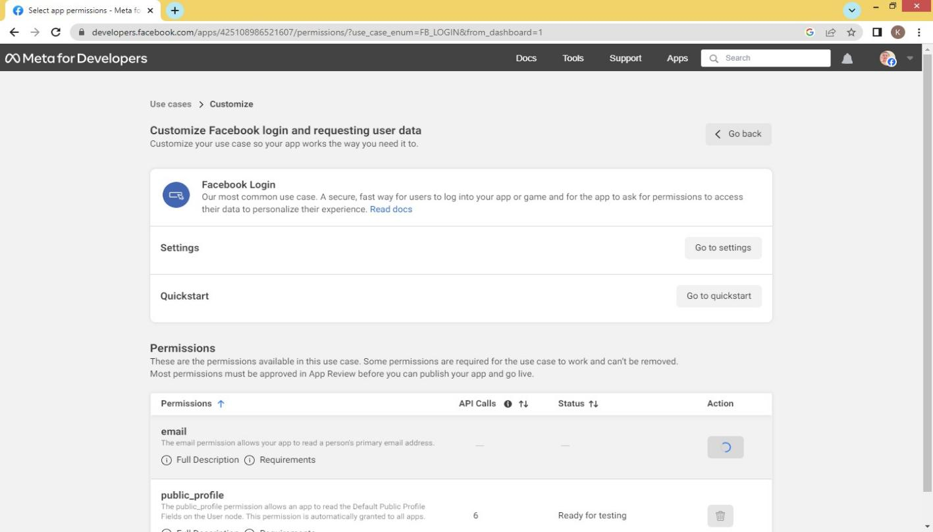

**Step 13**: Access The Fields Data Using Graph API Explorer

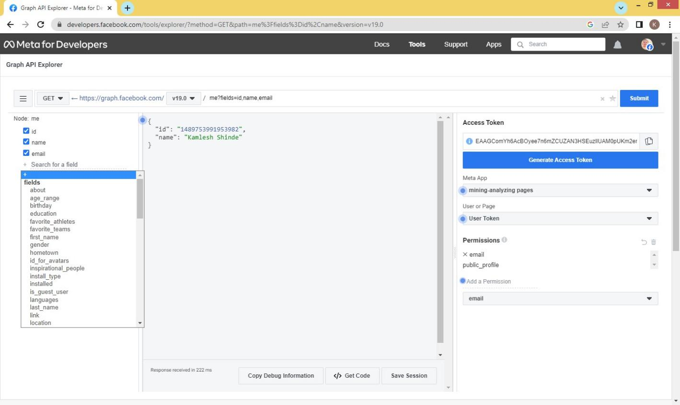

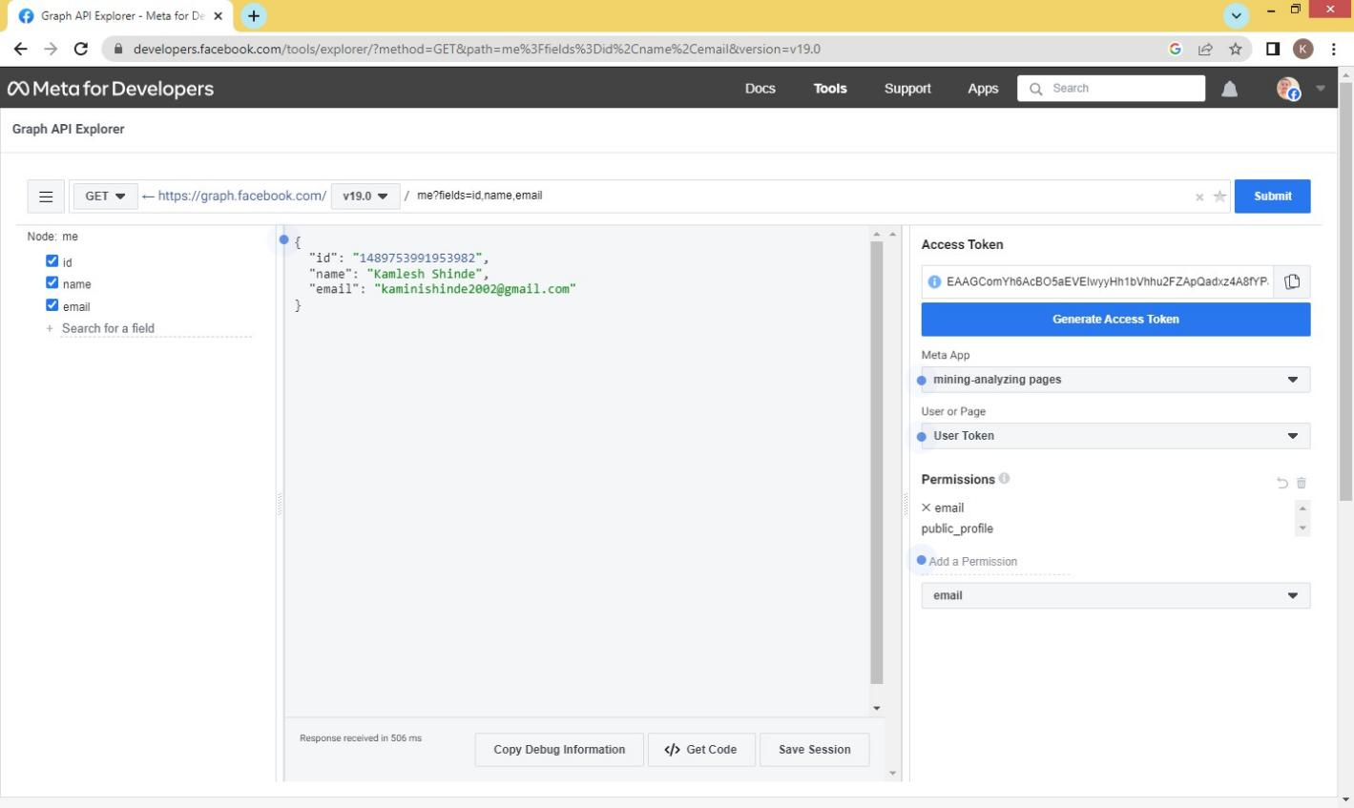

**Step 14:** Generate The Code For Android App

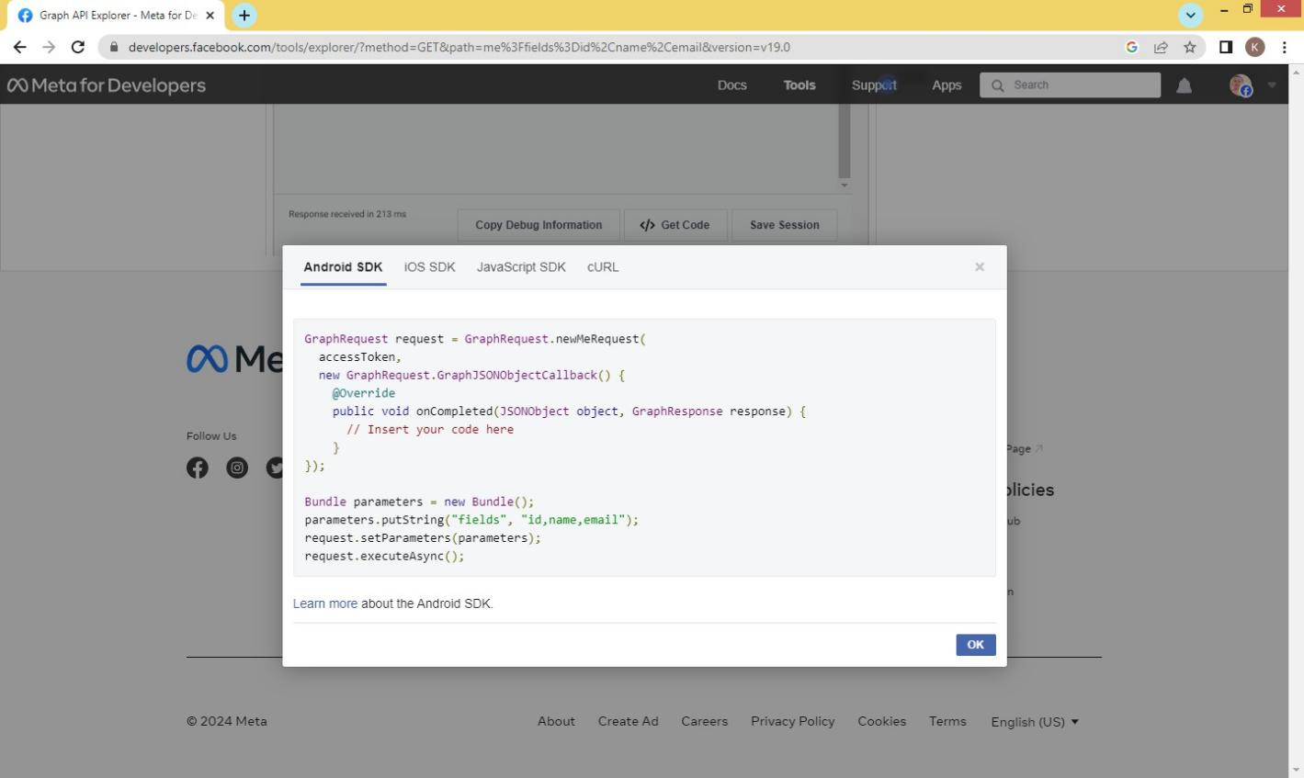

**Practical No 3: Segment Traffic: Which Social Channel Is Sending The Most Engaged New Users, Which Page Of Your Website Have Been Shared Most, Which URL Has The Best Engagement Matrix.**

**Roll No.:-**

**Step 1** : Login To The Google Account And Go To The Google Sites

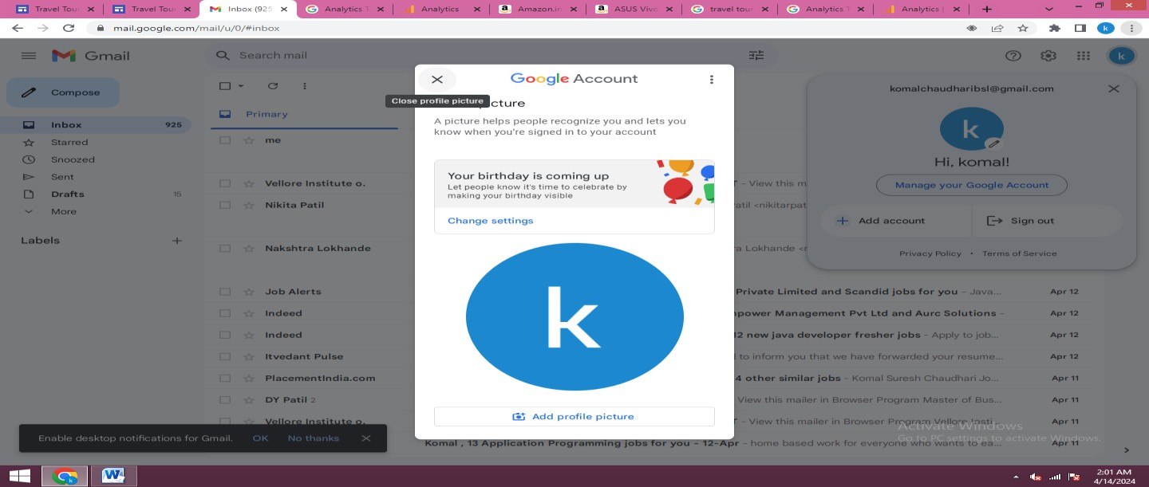

**Step 2:**Then Select Blank Sites

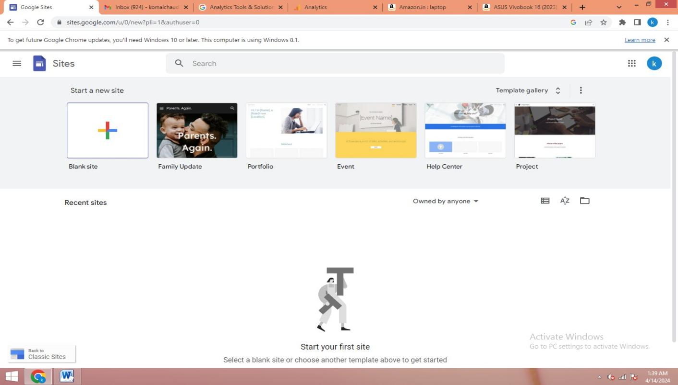

**Step 3**: Site And Add Title For Example (Tourist Spots) And Click On Publish.

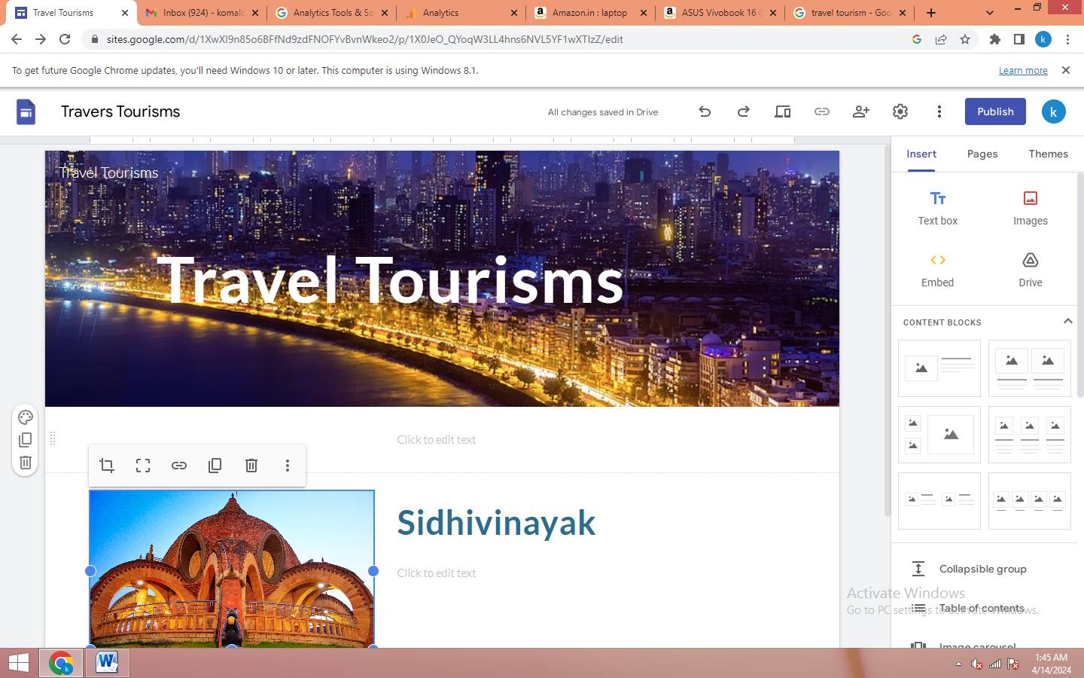

**Step 4**: Publish To The We(Travel-Tourisms) And Publish It .

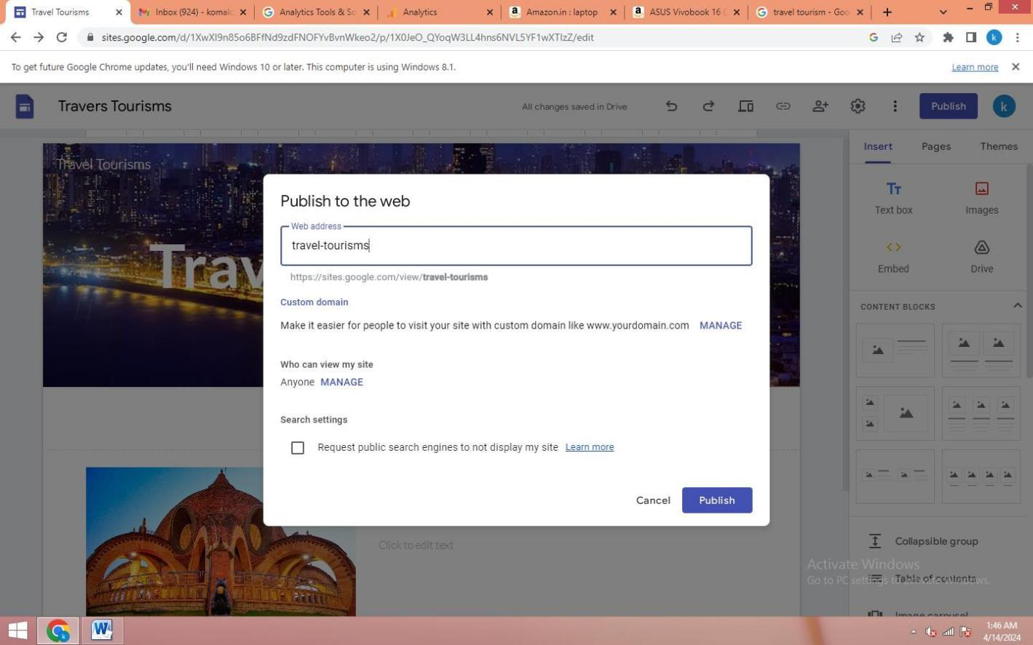

**Step 5:** After Publishing This Page Is Appear



**Step 6:** Go To The Google Analytics Tools

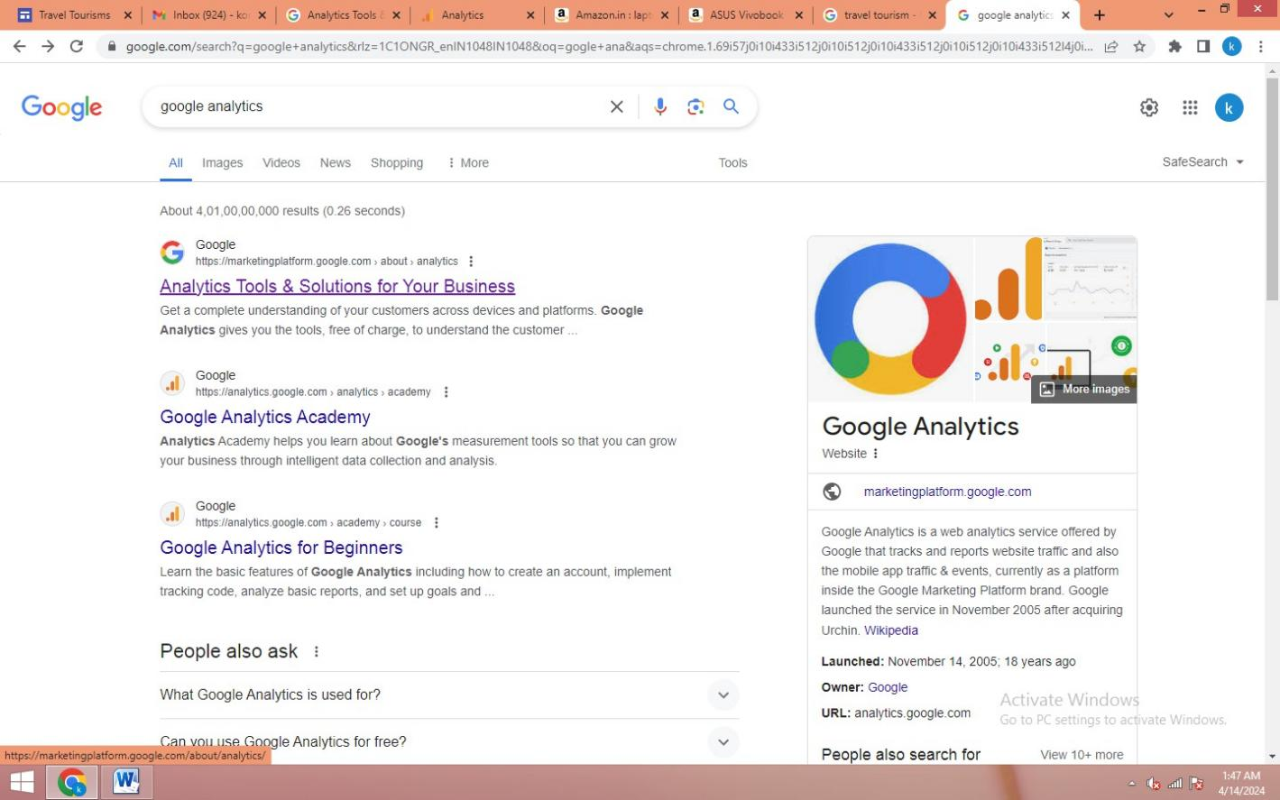

**Step 7**: Click On Get Started

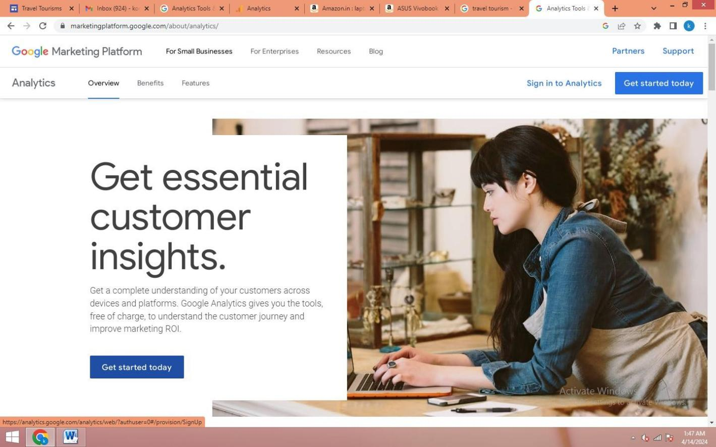

**Step 8:** Go To The Web Analytics And Create An Account For Ex(Travelling Tourism) The Click Next Button.

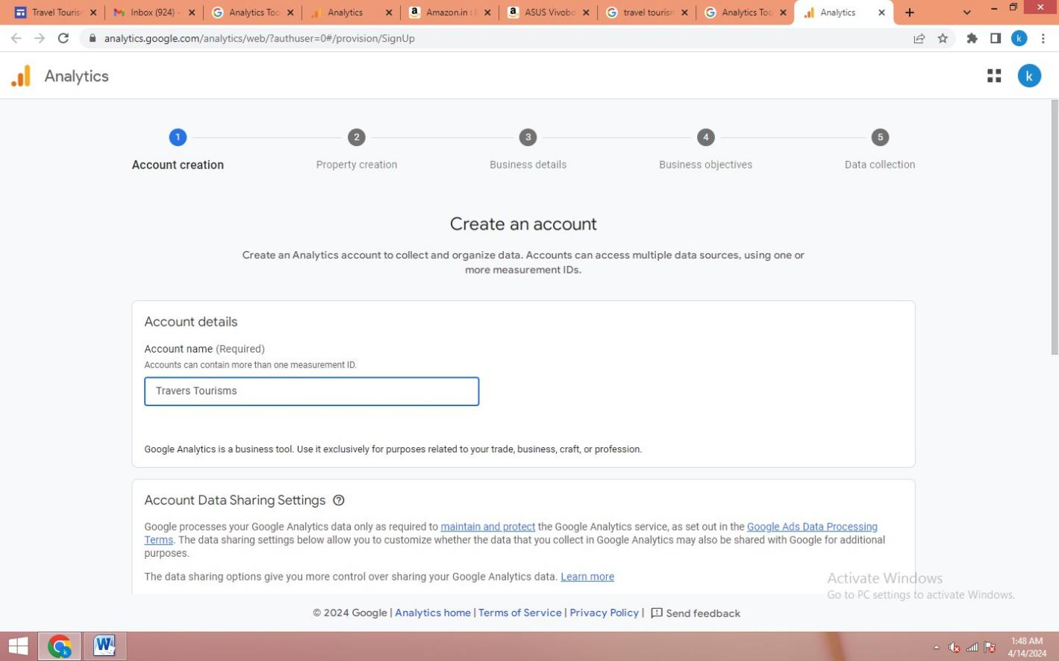

**Step 9:**Click Next Button And Create Your Property

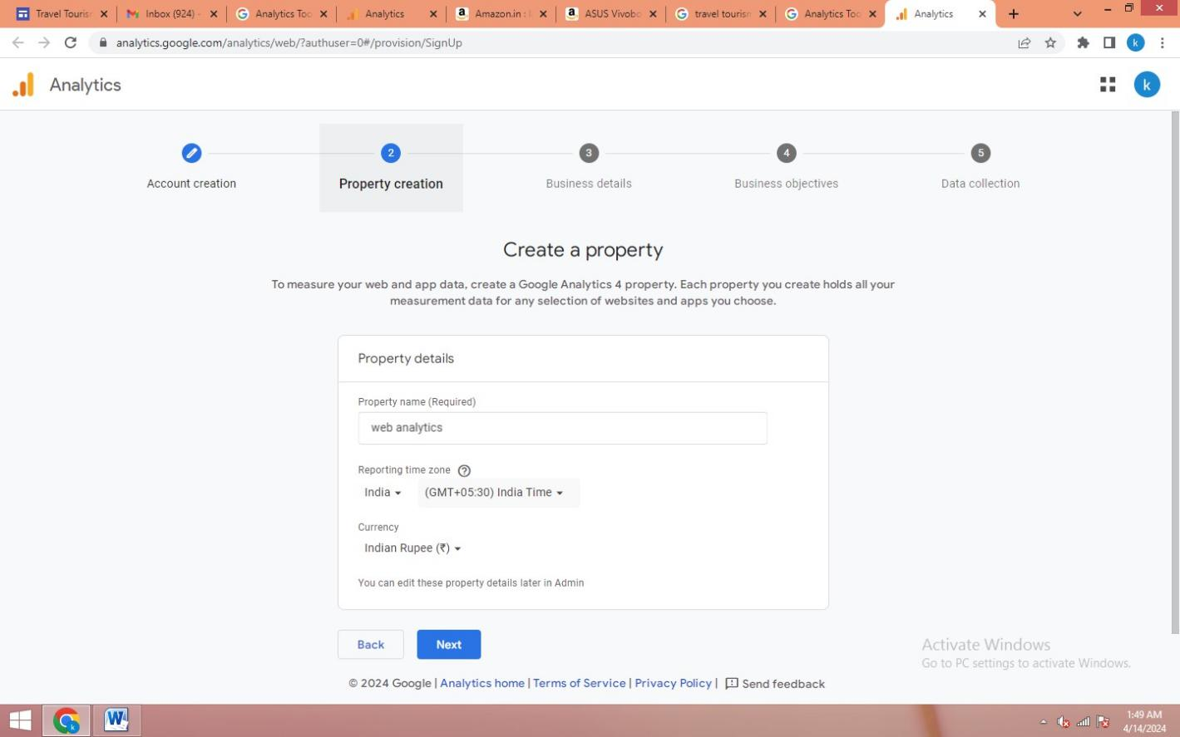

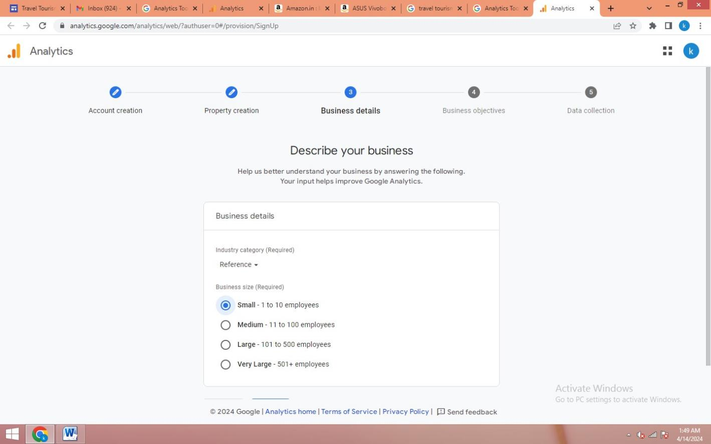

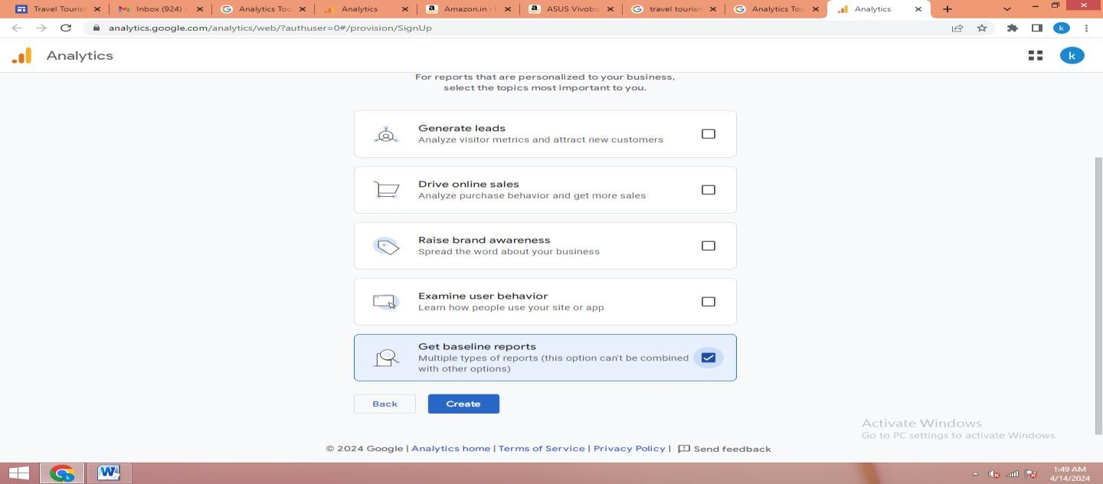

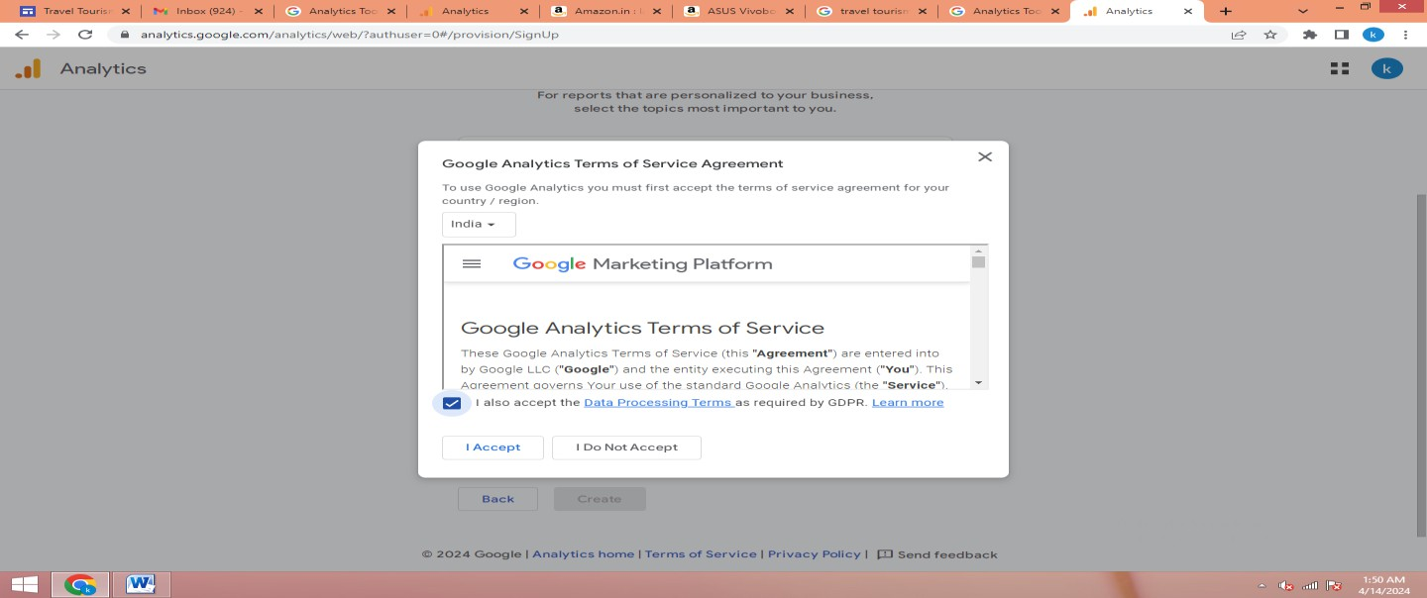

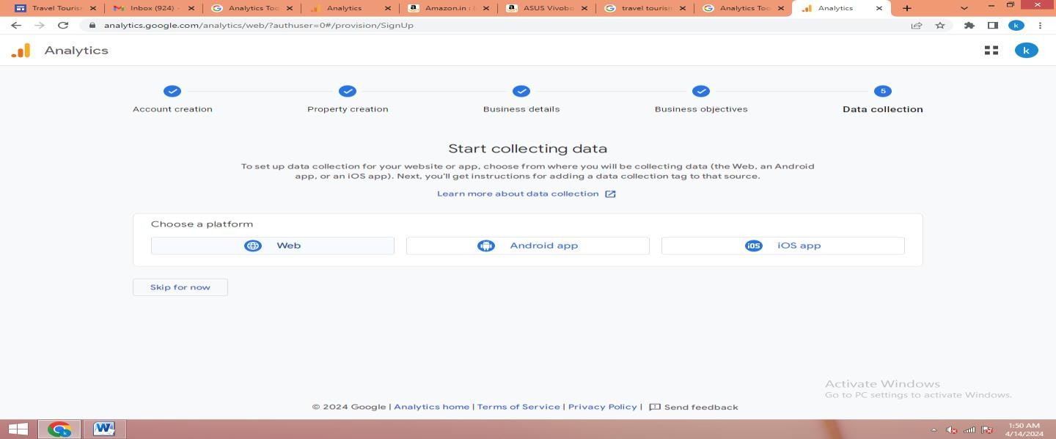

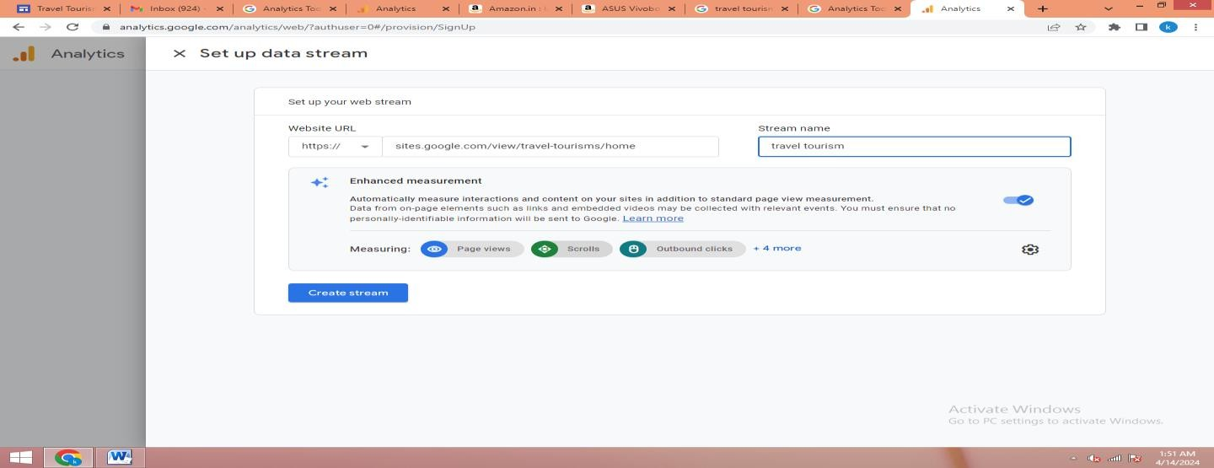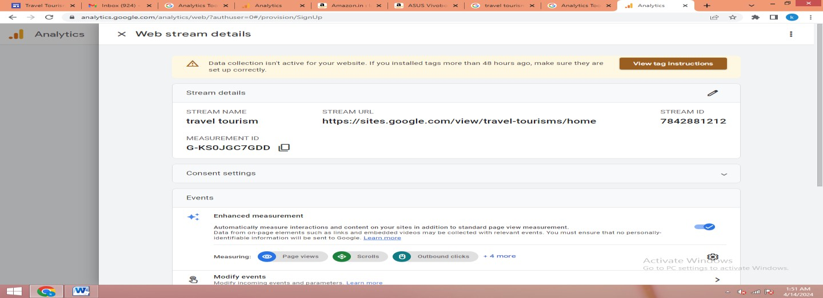

**Step 8:** Copy This Installation Instructions Code

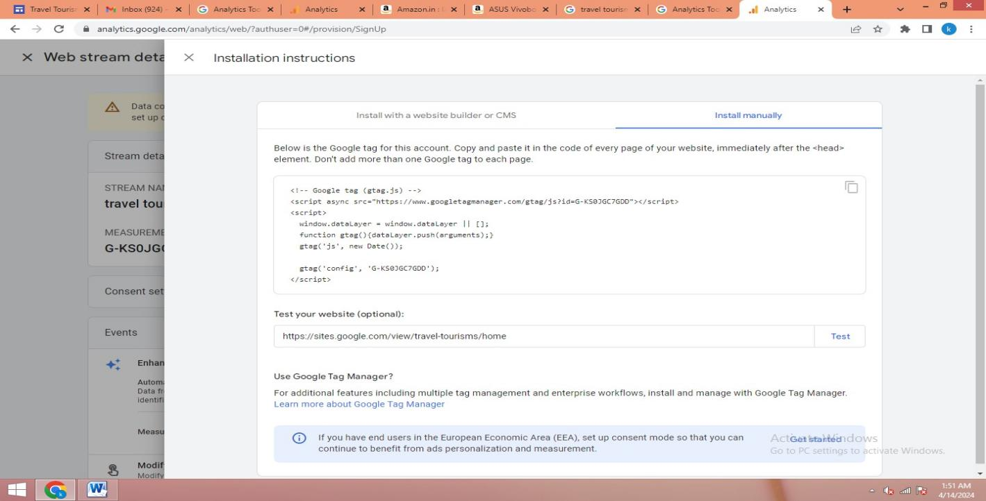

**Step 9:** Then Paste In Footer And Embed The Code

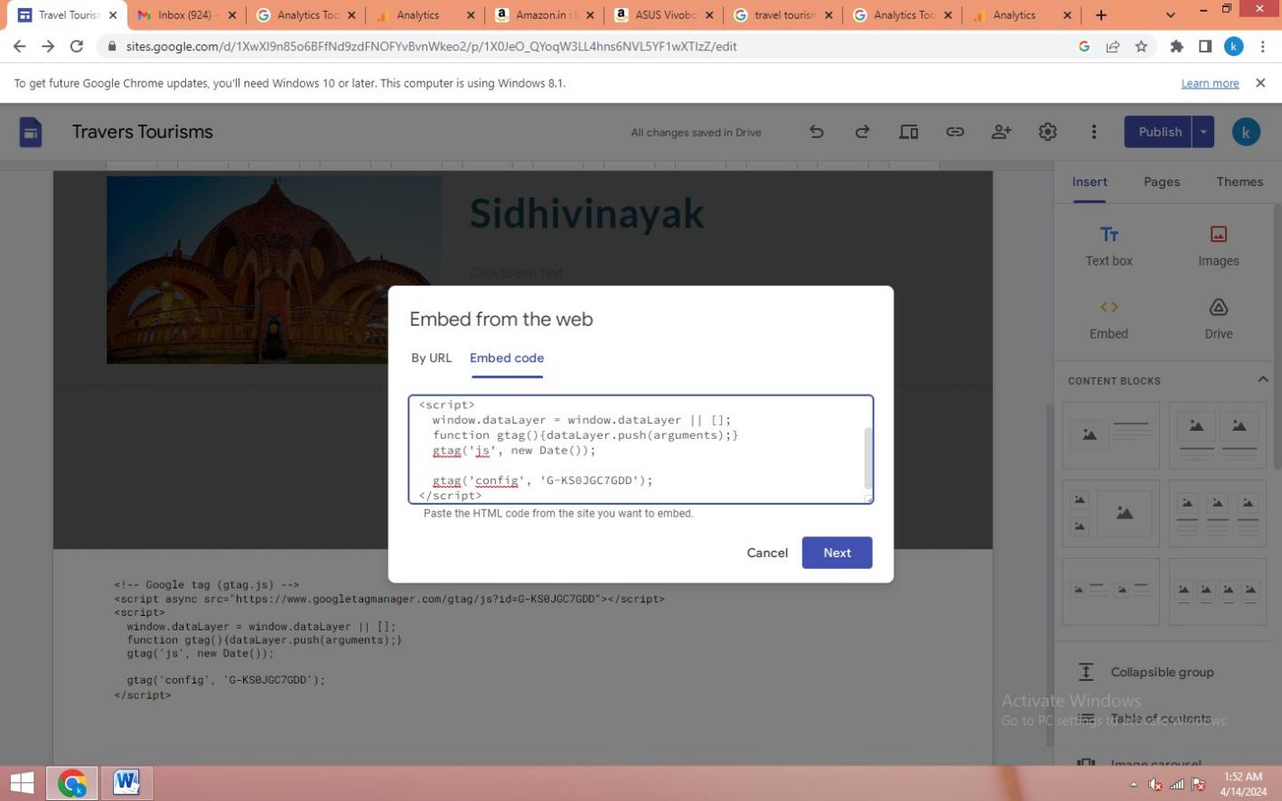

**Step 10**:After Paste The Code And Again Publish The Page

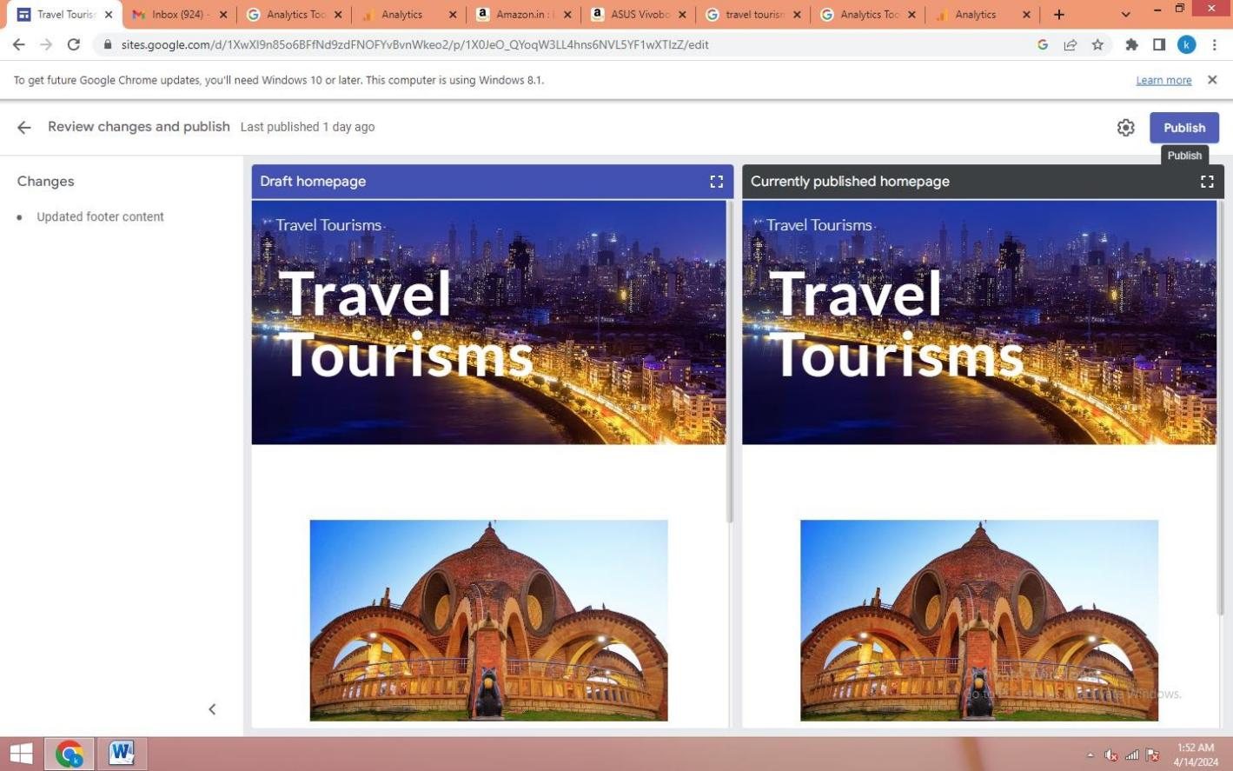

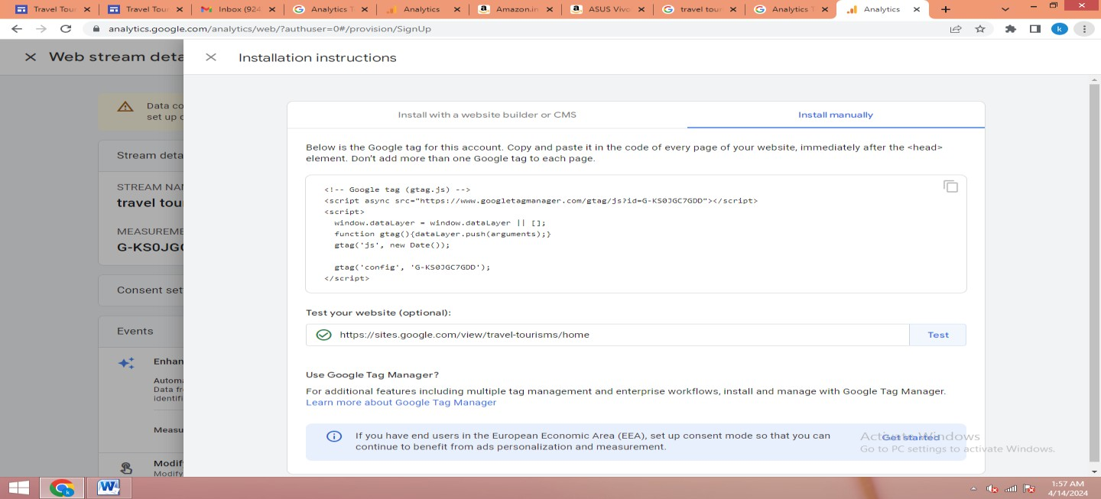

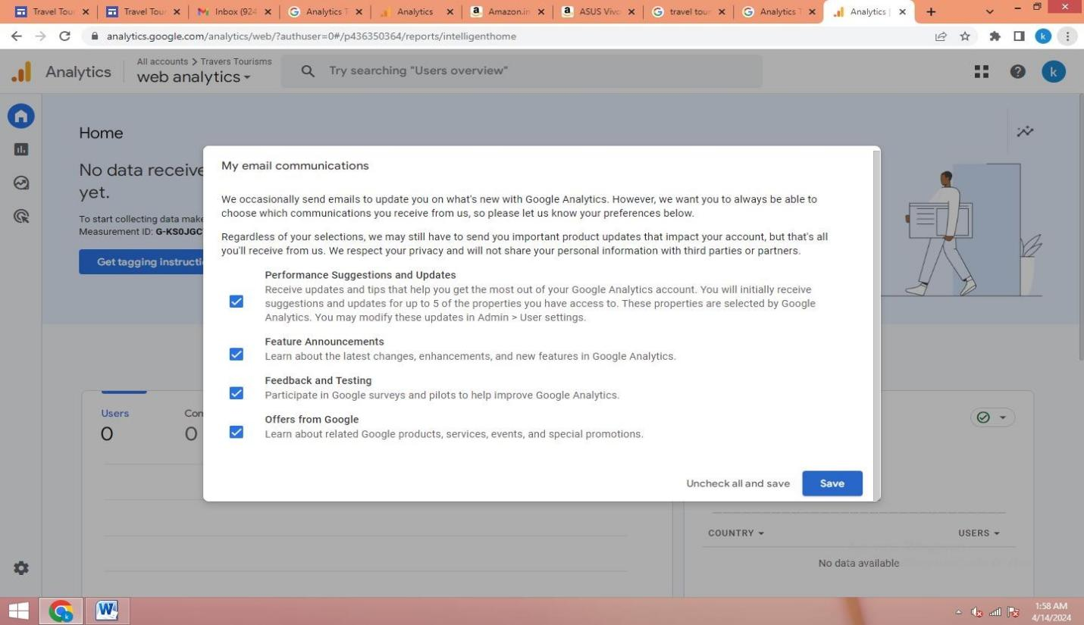

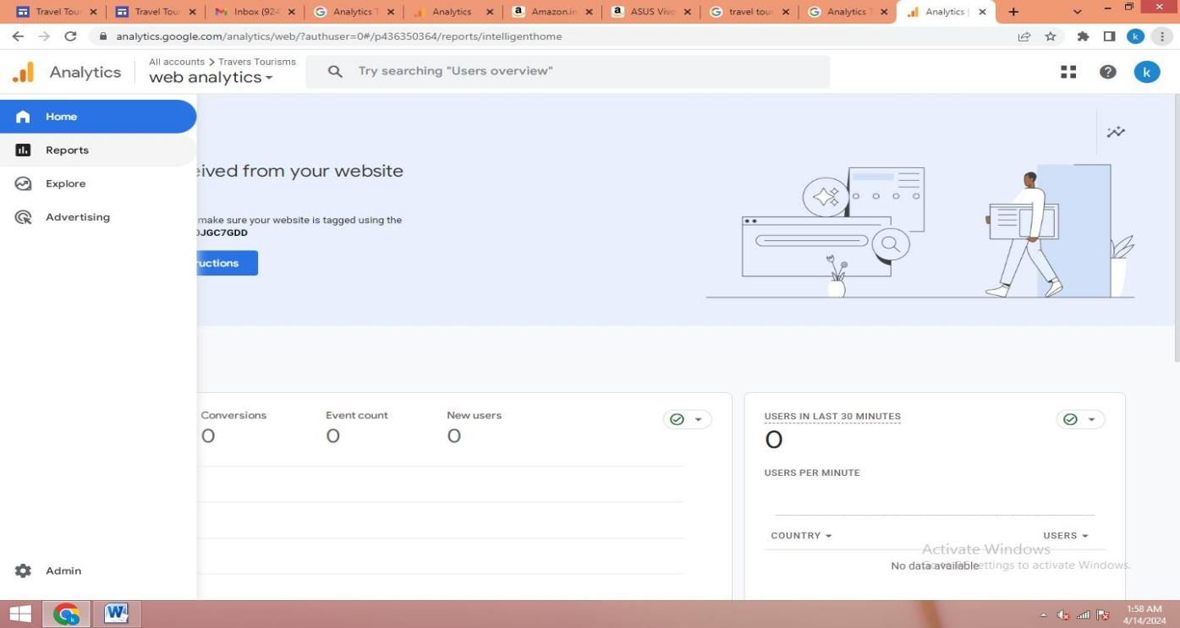

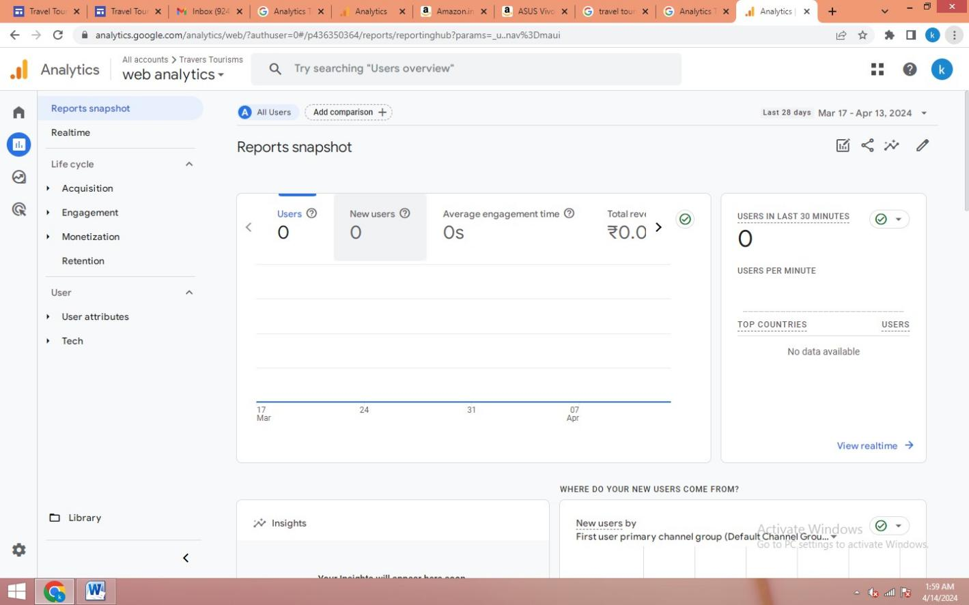

# Practical No. 4: Use Google Analytics To Measure The Various Metrics For E-Commerce Site Amazon. On-Site − It Measures The Users’ Behavior Once It Is On The Website. For Example, Measurement Of Your Website Performance. Off-Site − It Is The Measurement And Analysis Irrespective Of Whether You Own Or Maintain A Website. For Example, Measurement Of Visibility, Comments, Potential Audience, Etc.

**Roll No.:-**

**Step 1**:Login To The Google Account

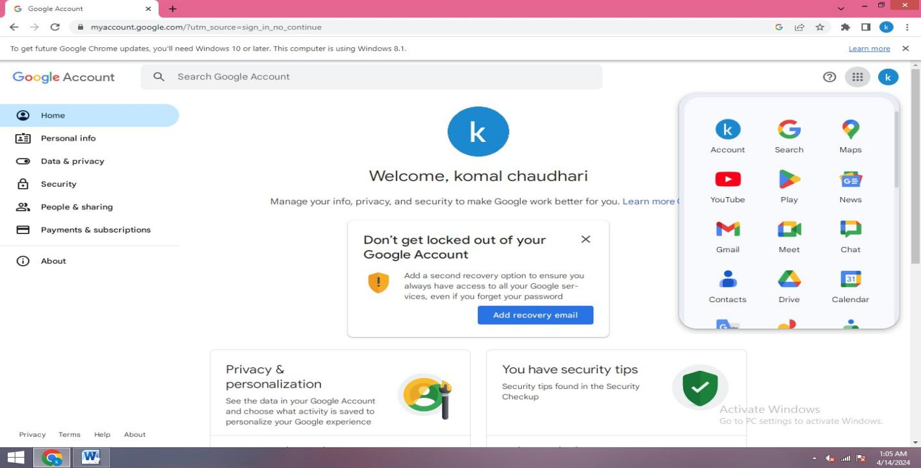

**Step 2**: Go To The Google Analytics Tools.

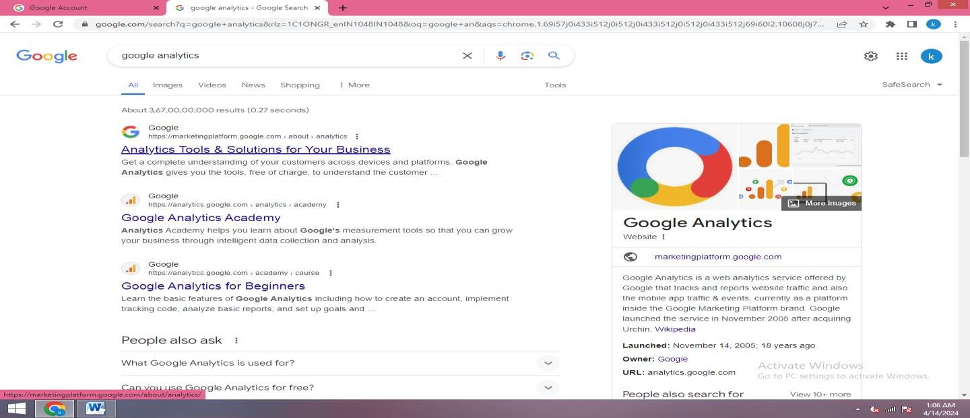

**Step 3:** Click On Get Started And Star Measuring And Create Your Account

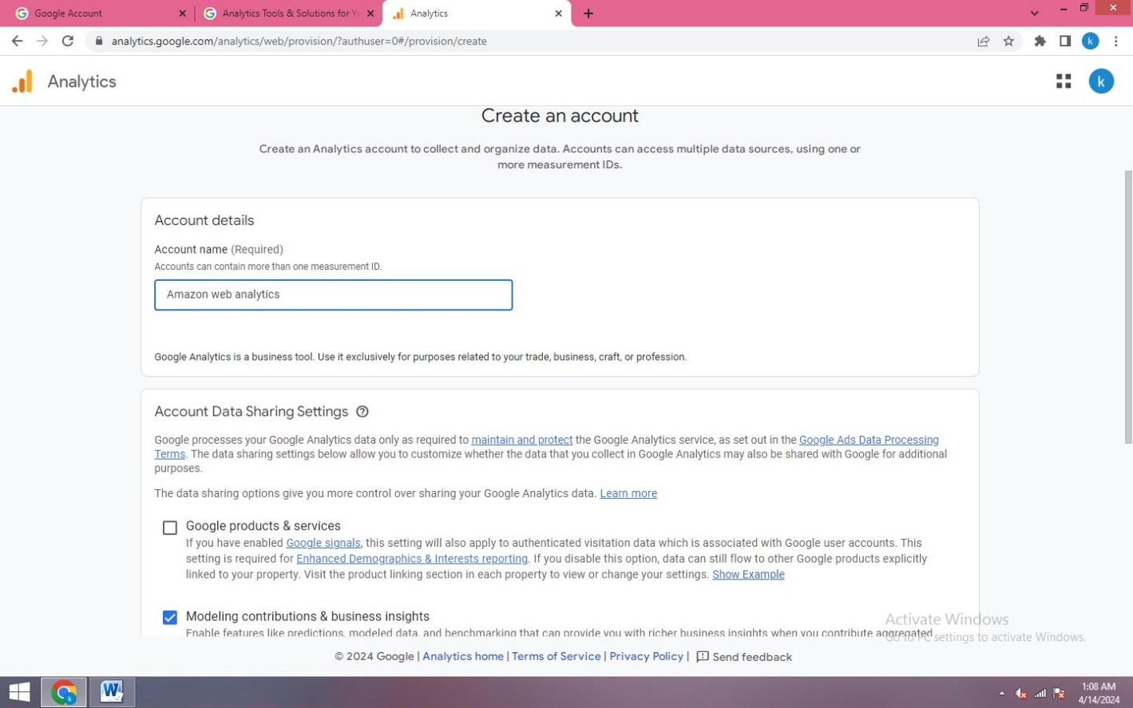

**Step 4:** Click Next And Create Your Property

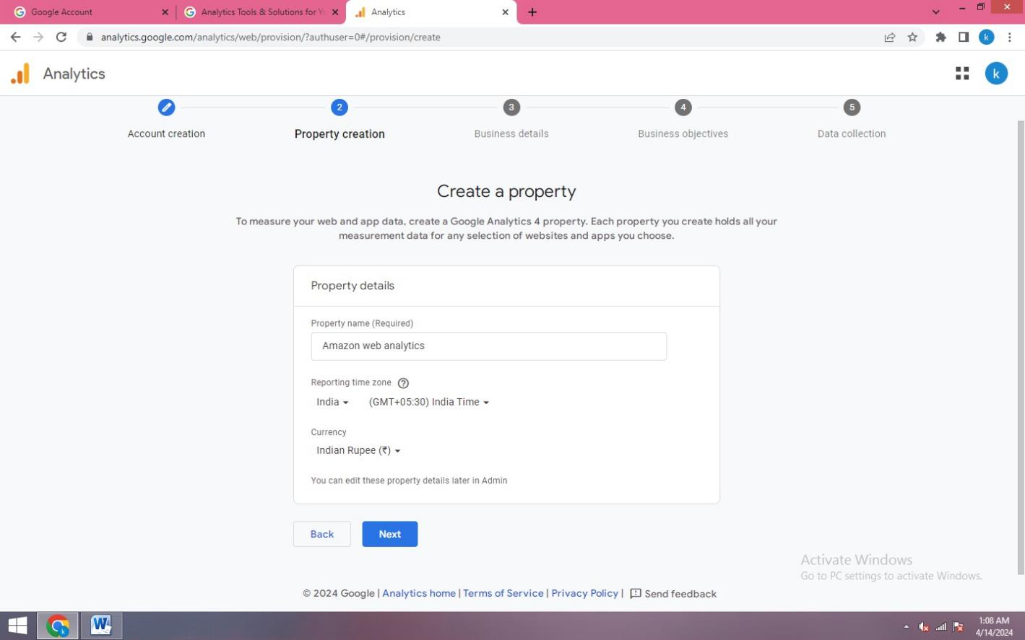

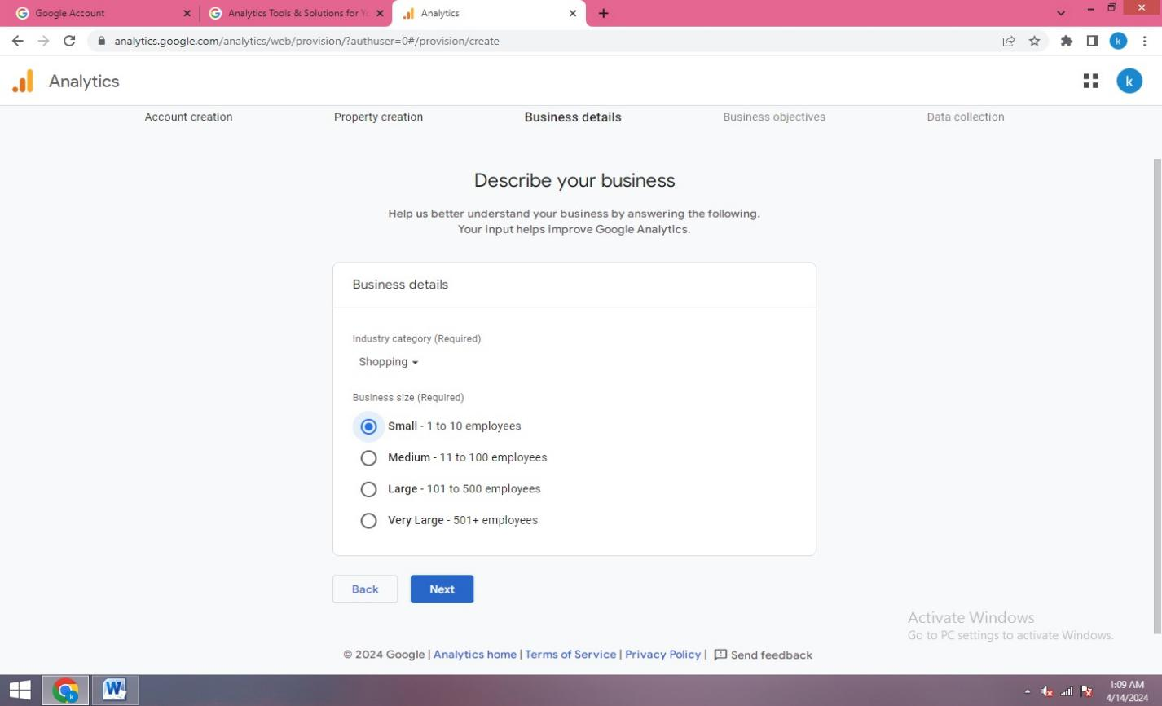

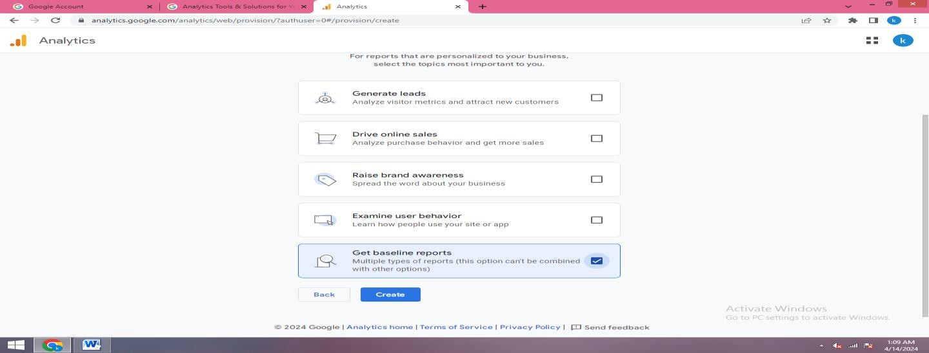

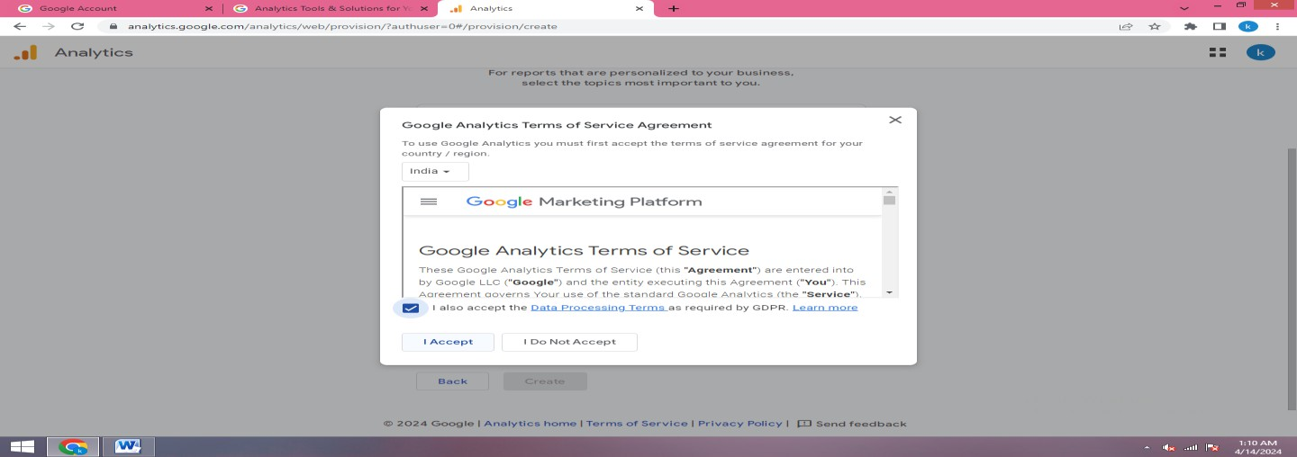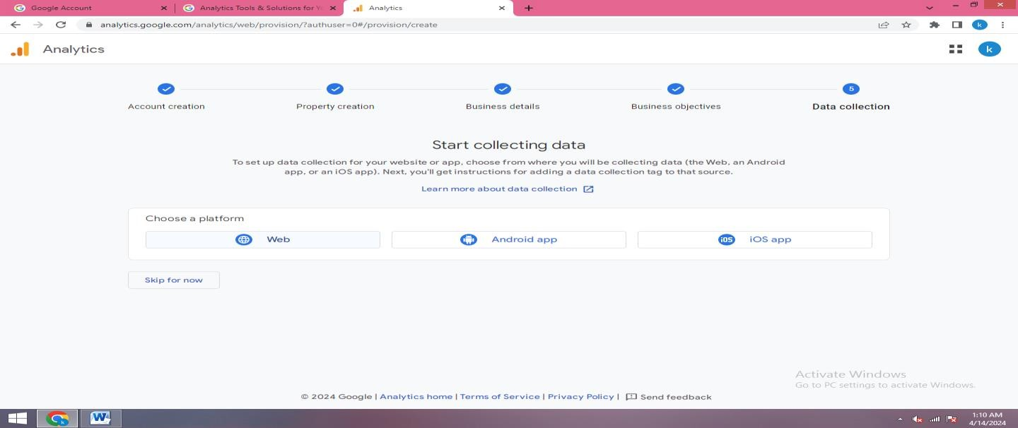

**Step 5** : Go The Amazon Website Select Your Product And Copy Product Address

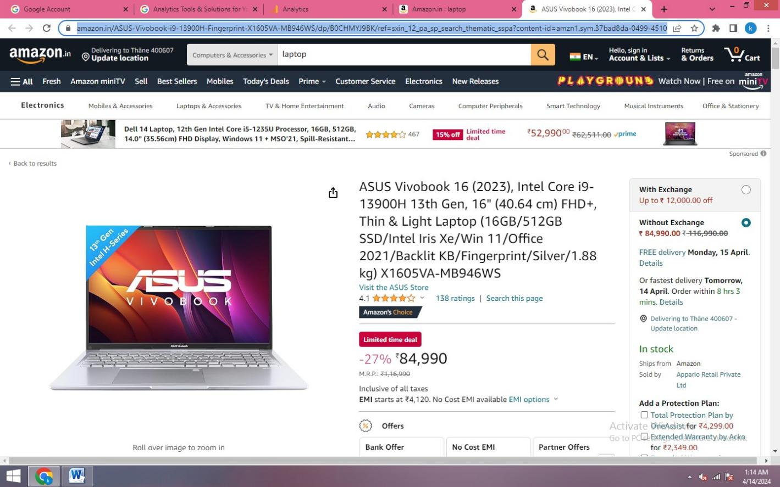

**Step 6:** Then Paste Our Product Address

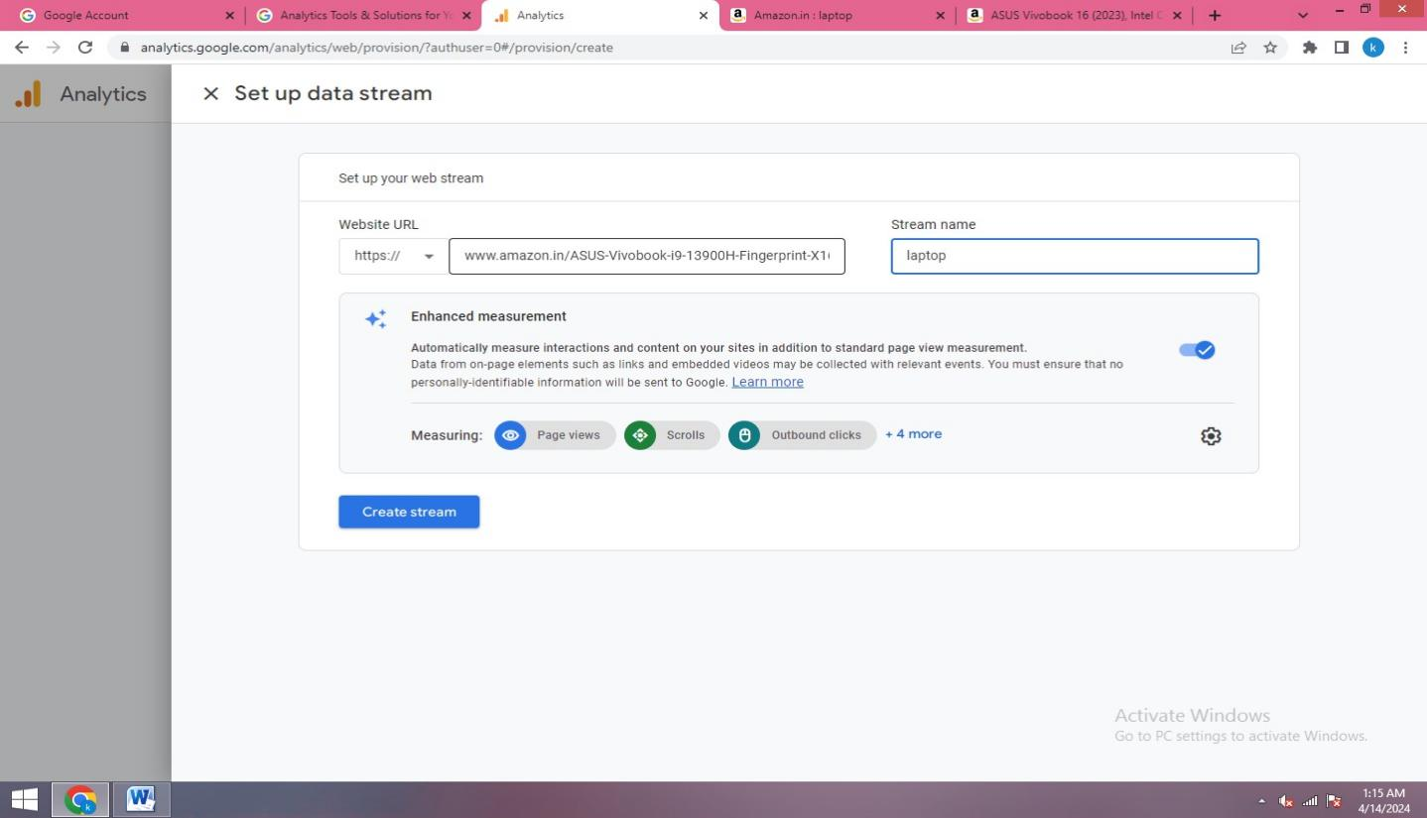

**Step 7:** Click Get Started Button

